**Jared Parkinson**

**Module 7: Assignment 1 Creating Dynamic View from the Query**

**EJS vs PUG**

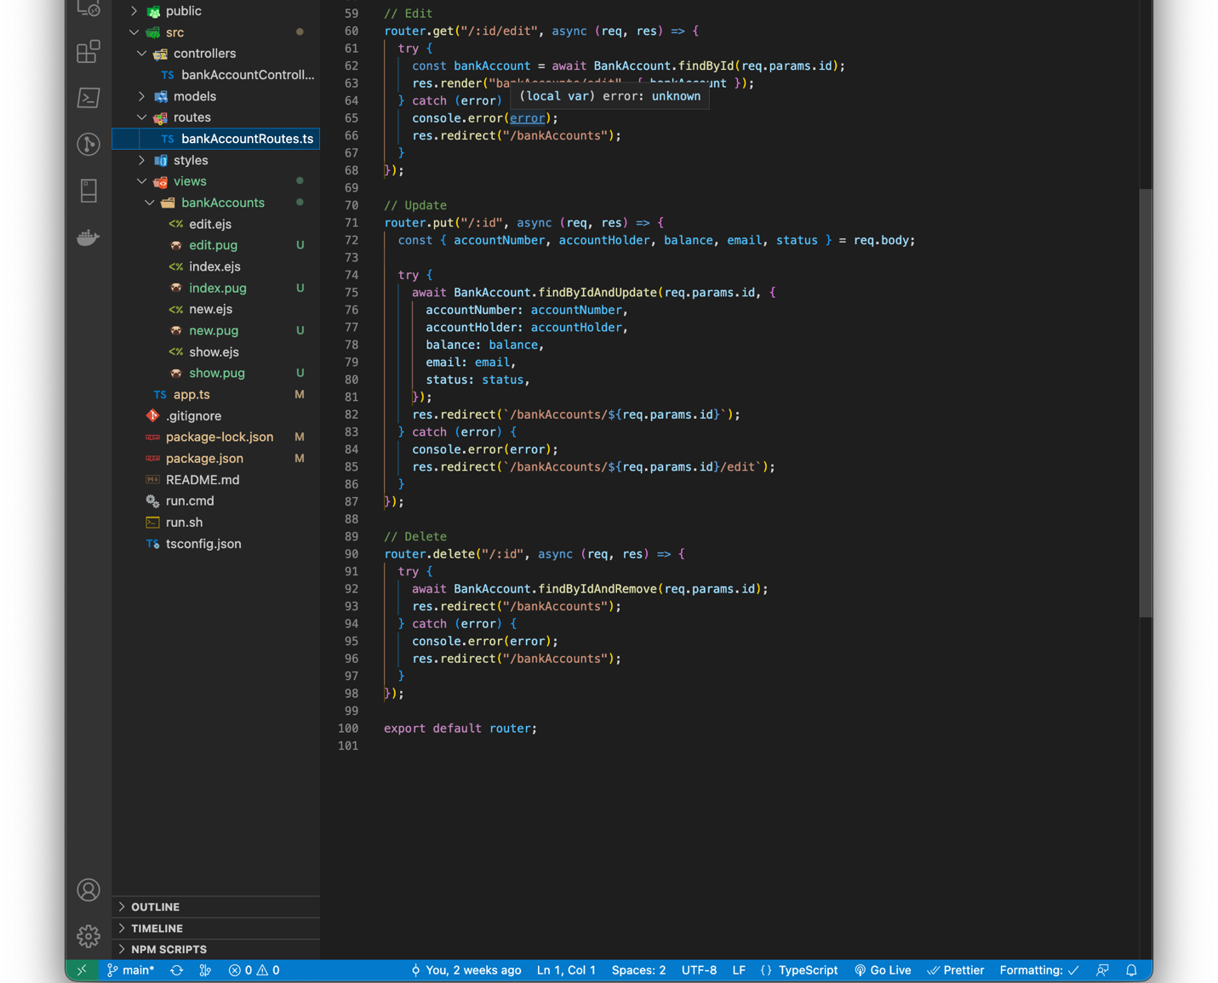

**EJS Tutorial**

